**IP (JavaScript Lab):**

**Before starting this lab once go through examples uploaded on teacher’s data** (\\printsrv\Teacher Data\Aisha\IP\post mid\JavaScript\Examples from Lecture**) it contains all the examples we discussed in class.**

**Task 1:**

Write a JavaScript program to calculate the volume of a sphere.  (Formula: 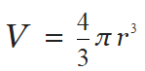)

*Sample Screen*:

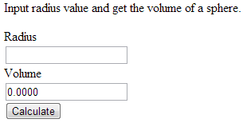

**Hint:** you can use **Math.pow(***base, power*) and **Math.PI**

**Task 2:**

Write a JavaScript program to construct the following pattern (i.e. a square), using a nested for loop.

*************

* *

* *

* *

*************

.

**Hint:**

* For this you have to write Script tag in body, NO buttons etc. are needed.
* To print on the page you can either use document.write() method OR innerHTML option of some tag as we discussed. Example of document.write() is given below.

|  |
| --- |
| <html>  <body>  <script>  document.write("Hello World!");  </script>  </body>  </html> |

**Task 3:**

JavaScript date object is used to create dates and times. Date objects are based on a time value that is the number of milliseconds since 1 January, 1970 UTC.

**Different Constructor:**

var d = new Date();  
var d = new Date(*milliseconds*);  
var d = new Date(*dateString*);  
var d = new Date(*year*, *month*, *day*, *hours*, *minutes*, *seconds*, *milliseconds*);

A sample on using date object is shown below (different available methods of date object e.g. toString(), getHours() etc are also used in this sample, more such method are given on your **JavaScript cheat sheet** *(that was distributed in class, soft copy is also places at (\\printsrv\Teacher Data\Aisha\IP\post mid\JavaScript)*, go through those once):

|  |
| --- |
| <html>  <body>  <p id="demo"></p>  <script>  var d = new Date();  document.getElementById("demo").innerHTML = d +  "<br/> toString() = " + d.toString() +  "<br/> toDateString() = " + d.toDateString() +  "<br/> getHours() = " + d.getHours() +  "<br/>" + d.toString() ;  </script>  </body>  </html> |

* Write a JavaScript function to get the number of days in a month (**Hint:** getDate() method is useful for this)
* Write a JavaScript function to test whether a date is a weekend **Hint:** getDay() method is useful for this)

|  |  |
| --- | --- |
| **Method** | **Description** |
| getDate() | Returns the day of the month (from 1-31) |
| [get](http://www.w3schools.com/jsref/jsref_getday.asp)Day() | Returns the day of the week (from 0-6) |

**Explore other date functions as well.**

**Task 4:**

As we discussed in class, random number can be generated using Math.random() (by default between 0[inclusive] and 1[exclusive]) in javascript. A sample code snippet is given below:

|  |
| --- |
| <html>  <body>  <script>  var d = Math.random();  alert("random number = " + d);  </script>  </body>  </html> |

Create a page with one textbox and a button (As shown below). Also, write JavaScript code where the code generates a random integer between 1 to 10, we’ll call it **guess number**.

User can inputs a number in textbox. And clicks ‘*Check my Guess,* button. If the user input matches with the **guess number**, the program will display will show an alert with message "Good Work" otherwise shows "Not matched".

*Sample Screen* :

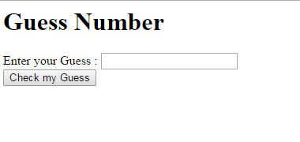

**Task 5:**

You can deal strings as arrays as well in JavaScript as shown below:

|  |
| --- |
| <html>  <head>  <script>  function showChars()  {  var str="abcde";  for (i = 0; i < 5; i++) {  alert(str[i]); }  }  </script>  </head>  <body>  <input type="button" value="Basic Loop Demo" onclick="showChars()"/>  </body>  </html> |

Create page that takes a string as input from user in textbox and it has different buttons for each of the following operations

* **CountWords:** takes a string and counts the number of words in string.
* **CoverttoCamelCase:** Takes a string and converts first letter of each word of string in upper case.
* **SearchCharacter:** Takes a string and a character (place another textbox to get character input) as input and searches if the entered character exists in string.

**Appropriate output for each of above should be shown in alert box.**